Keeping me involved while I wait to move


Some people like to know everything about moving.

And some people only want to be told once things are decided for certain.

This is printable so you can make a plan about how much you want to be involved.

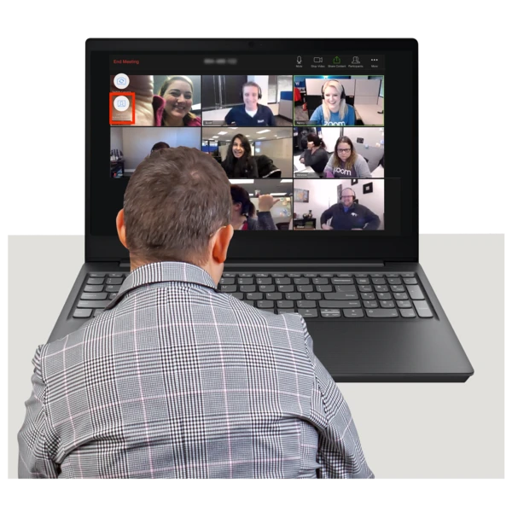

▢ I want to come to all the meetings I can.

▢ I want to come just for the start of the meetings.

▢ I want to come just for the end of the meetings.

▢ Other ideas:

Remembering what was said

Sometimes lots and lots of things get talked about at a meeting.

It can be hard to keep track of it all.

Your team can help you by communicating with you clearly.


▢ I want a summary letter after each meeting

▢ I want a recording of a summary about the meeting

▢ I want a video summary about the meeting


▢ I want someone [who…………] to tell me the most important parts of the meeting

▢ I would like ……………. to help me take notes in the meeting

▢ Other ideas:

