A focus on practical stuff: what you will find in this section of the website

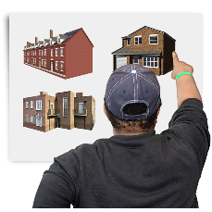
Moving can involve a lot of planning and decisions to be made. Some of these decisions can be fun and easy, others can be more difficult

There is a lot of information split into 3 sections with links, videos, and checklists to complete

Before moving:
- Steps involved in planning a move
- Your choices and decisions
- What other people can do to help

Waiting to move:
- Who is involved
- Ideas of things to do whilst waiting
- Ideas for planning to say ‘goodbye’

After moving:
- Keeping safe in and out of your home
- Managing your money
- When things go wrong

There is also information those who support you may find helpful

We hope you find this section useful

You can contact us on social media: Facebook (Making Positive Moves), Twitter (@moves_positive) and Instagram (@makingpositivemoves). Or email us at: hello@makingpositivemoves.org

